**Monitoring Humidity and Temperature using Bluetooth and WIFI module via Android device.**

**BHARGAV PETLA**

**18070**

**I. INTRODUCTION**

Monitoring is considered to be an essential aspect of environmental changing conditions. Monitoring of temperature and humidity is employed to assess and mapping of biodiversity over vast regions, in alerting of any changes to the climate conditions. Measurement and maintaining constant temperature are also important in industrial processes. Temperature transducers which are used in electrical measurements are numerous due to a wide range of temperatures being measured, and because of the measurement accuracy in a specific area. Humidity is the amount of water vapor that is contained in a sample of air. It is a very important feature of the air both in terms of weather as well as in terms of bioclimatic. In this project, we use an IOT based system to monitor the temperature and humidity and send that data to an android device. Today in the modern-day scenario we want reliable transmission of data and the reliable transmission of data can be provided with the help of wifi and Bluetooth module. Nowadays wireless Communication becomes a spectrum by which we can send innumerable data streams from one channel to the other channel. The system involves the transmitter part and the receiver part which are used for transmitting and the reception of data. We collect the data using the temperature and humidity sensor DHT11 and send it to the android device using a Bluetooth module. The sensor used to measure humidity is the DHT22 sensor. The DHT22 is a basic, low-cost digital temperature and humidity sensor. It uses a capacitive humidity sensor and a thermistor to measure the surrounding air and spits out a digital signal on the data pin (no analog input pins needed). It's fairly simple to use but requires careful timing to grab data. The Bluetooth module used here is HC05 which is a four-pin Bluetooth module that is used for the interfacing purpose with that of the Arduino board. This board is chosen because of its high demand and availability in the market. The Bluetooth which we are using here takes care of a short range of distance. i.e within this short range, the data can be transmitted from the Arduino to android. Arduino serves as the platform of hardware configuration and whereas the main media for transferring the data can be served with the Bluetooth module and apart from this, the coding for manipulation is done in the Arduino software environment which is a simple IDE environment used for uploading the sketches. Nowadays android phone has a quite efficient demand in the market due to its’s high superior manifestation in the market compared to the earlier operating systems which were expired now due to the modern-day motivation and the innovation in the technology department. With the help of the pairing between Arduino and the Bluetooth module, we are going to send the data whereas this android part acts as a receiver one, and the Arduino acts as a transmitter. Here in the case of transmission and the reception of data the default band rate is considered which is in the range of 9600.

**II. METHODOLOGY**

**2.1 MATERIALS**

Arduino Uno Board:

The Arduino Uno is an [open-source](https://en.wikipedia.org/wiki/Open-source) [microcontroller board](https://en.wikipedia.org/wiki/Microcontroller_board) based on the Microchip ATmega 328p microcontroller and developed by [Arduino.cc](https://en.wikipedia.org/wiki/Arduino). The board is equipped with sets of digital and analog input/output pins that may be interfaced to various [expansion boards](https://en.wikipedia.org/wiki/Expansion_board) (shields) and other circuits. The board has 14 digital I/O pins (six capable of [PWM](https://en.wikipedia.org/wiki/Pulse-width_modulation) output), 6 analog I/O pins, and is programmable with the Arduino IDE (Integrated Development Environment), via a type B [USB cable](https://en.wikipedia.org/wiki/USB_cable).

Breadboard:

The Breadboard is used as a connecting of the hardware samples with it with the help of connecting wires and the different interface mechanisms. In this project, the breadboard is used to connect the peripherals of the Arduino and the Bluetooth module.

Connecting wires:

The connecting wires are used to interface between the Arduino and alongside that of the Bluetooth module. The Arduino board is fixed on the breadboard and the receiver module of the Arduino is connected with that of the Bluetooth module to provide high ended reliable and efficient mode of communication. The connecting ends of the Arduino board are connected with that of the Bluetooth module and the connecting parts are explained as below:-

* TX OF Arduino is connected with RX of Bluetooth module
* RX of Arduino is connected with that of the TX of the Bluetooth module
* Vcc is connected to a 5V power supply
* Gnd of Arduino board is connected with the Gnd pin of the Bluetooth module.

The above mentioned are the different connections that are used to interface between the Arduino board and the Bluetooth module.

LCD display:

In 16x2 LCD there are 16 pins overall if there is a backlight, if there is no backlight there will be 14 pins. One can power or leave the backlight pins. Now in the 14 pins, there are 8 data pins (7-14 or D0-D7), 2 power supply pins (1&2 or VSS&VDD or GND&+5v), 3rd pin for contrast control (VEE-controls how thick the characters should be shown), and 3 control pins (RS&RW&E).

PIN1 or VSS to ground

PIN2 or VDD or VCC to +5v power

PIN3 or VEE to ground (gives maximum contrast best for a beginner)

PIN4 or RS (Register Selection) to PIN0 of ARDUINO UNO

PIN5 or RW (Read/Write) to ground (puts LCD in read mode eases the communication for user)

PIN6 or E (Enable) to PIN1 of ARDUINO UNO

PIN11 or D4 to PIN8 of ARDUINO UNO

PIN12 or D5 to PIN9 of ARDUINO UNO

PIN13 or D6 to PIN10 of ARDUINO UNO

PIN14 or D7 to PIN11 of ARDUINO UNO

DHT11:

The DHT11 is a basic, low-cost digital temperature and humidity sensor.

**2.2 CIRCUIT DIAGRAM**

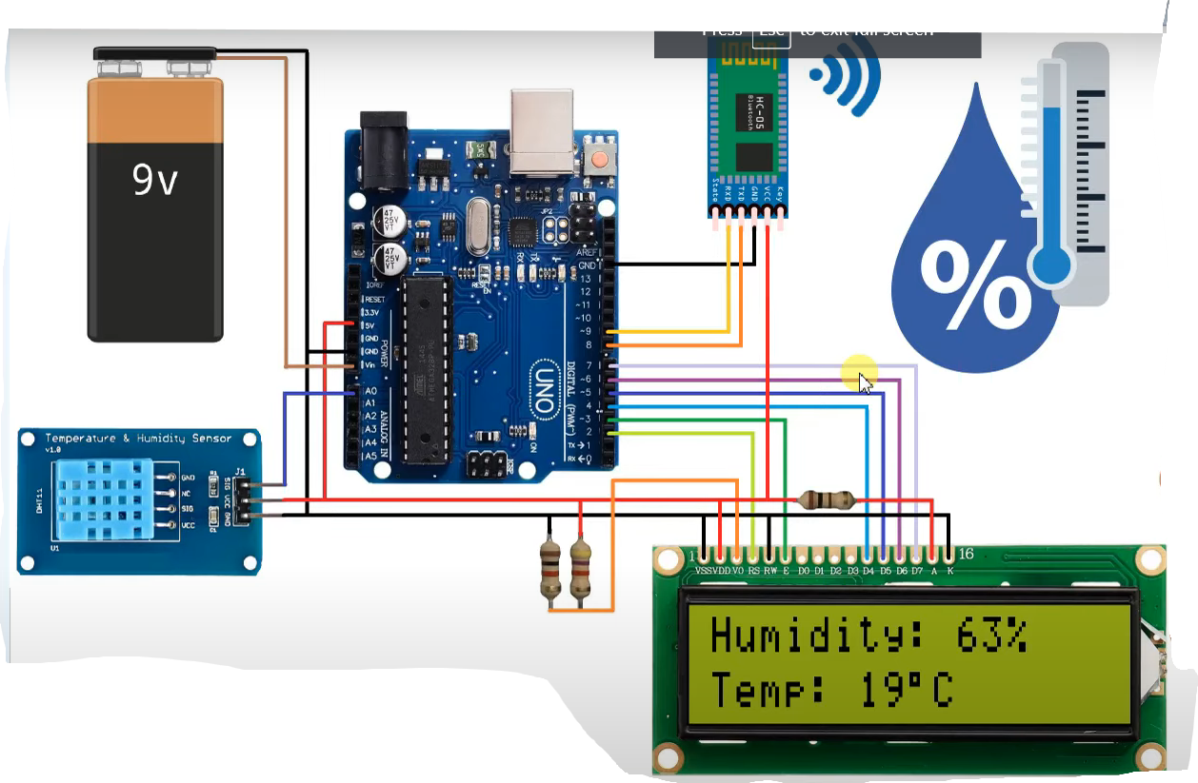

Hardware Representation:

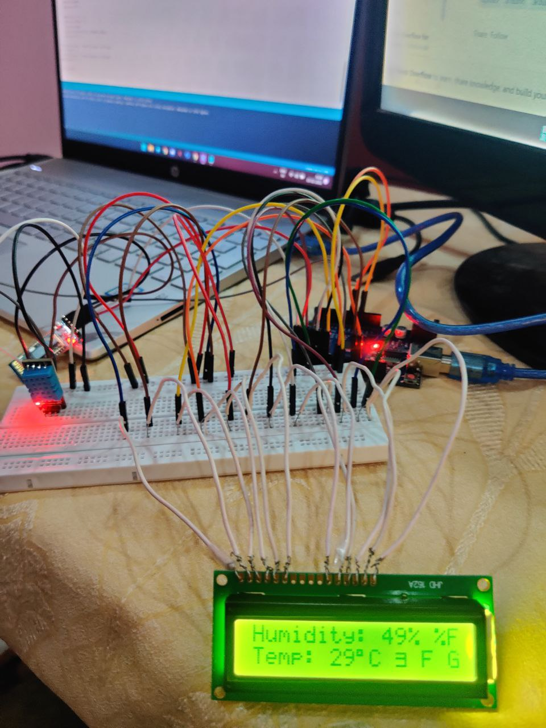

**2.3 METHOD:**

STEP 1:- Arduino Uno fitted in the breadboard.

STEP 2:-connecting HC05 Bluetooth module on the breadboard.

STEP 3:-connecting the pins of the Arduino nano board with that of the Bluetooth pins and the connecting

With the help of these things, verification and compilation are achieved.

STEP 4:-connecting DHT11 pins to the Arduino UNO.

STEP 5:-uploading the sketch in the Arduino software

STEP 6: Before uploading the software the receiver parts are disconnected and the sketch is uploaded.

STEP 7:-On successful compilation the temperature and humidity are displayed on the android and LCD screen.

STEP 8:- Create an android app using MIT app inventor.

STEP 9:-The android phone is the receiver part and with the help of these, we can get the information from the Arduino board.

How to connect Arduino to android:

Step-1 Step-2 Step-3

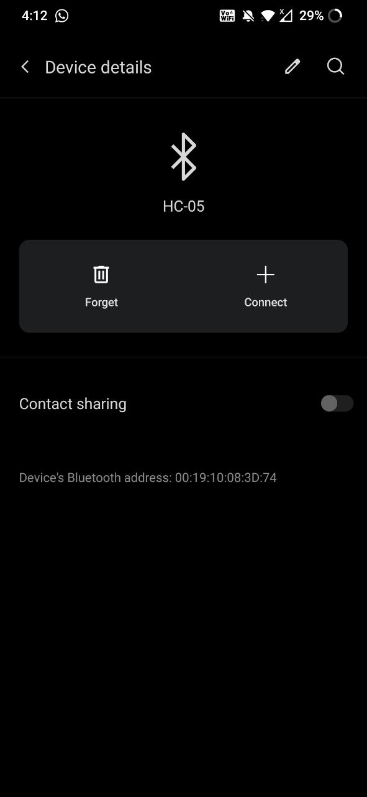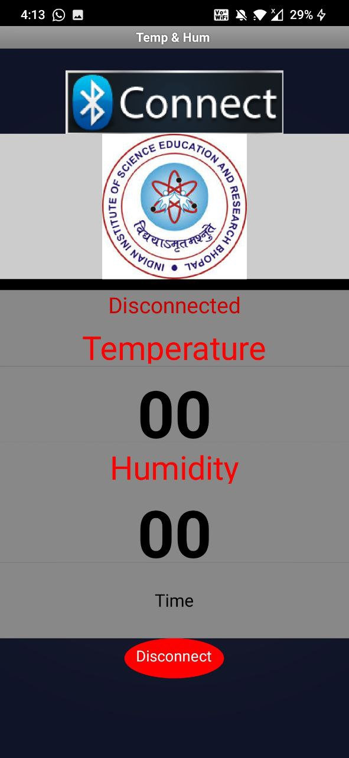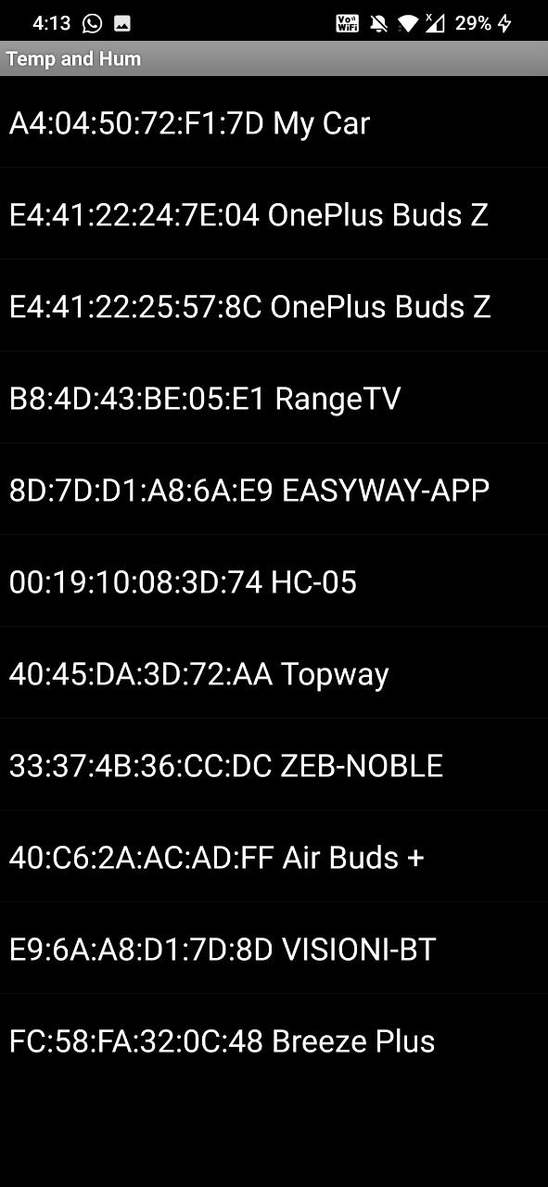

**III. RESULTS AND DISCUSSION:**

Temperature is 29C

Humidity is 49%

Bluetooth Module HC-05 is connected to Arduino to sent output to MIT App.

Serial Monitor output

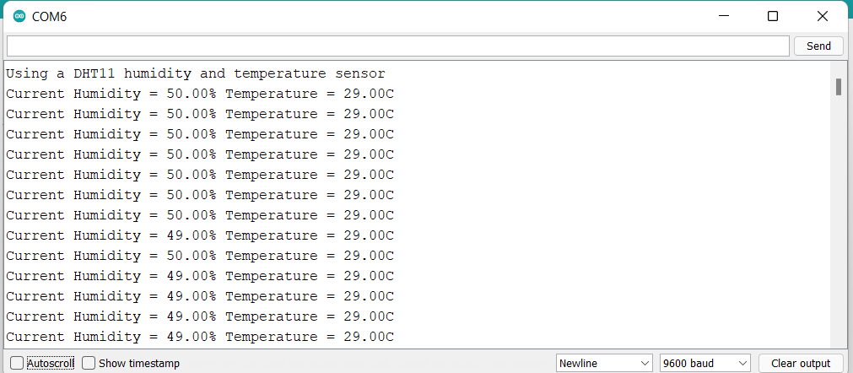

Android Output:

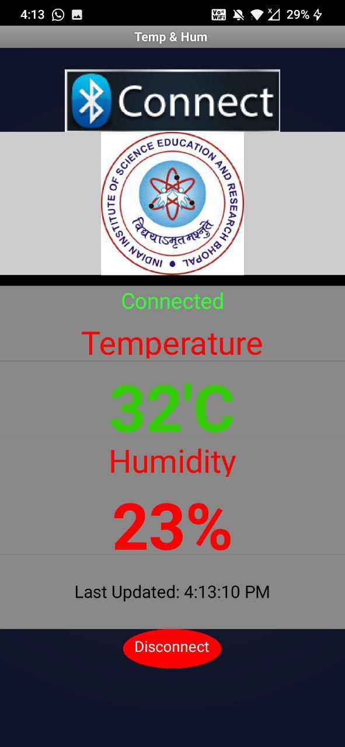

DHT22 uses a capacitive humidity sensor and a thermistor to measure the surrounding air and spits out a digital and HC 05 works in serial communication. The android app is designed to receive serial data from the Arduino Bluetooth module. The Arduino Bluetooth module at the other end sends the data and receives it through the TX pin of the Bluetooth module (Connected to the RX pin of the Arduino). The code uploaded to the Arduino checks the received data and compares it.

Github link for app and code: